1. Get all documents

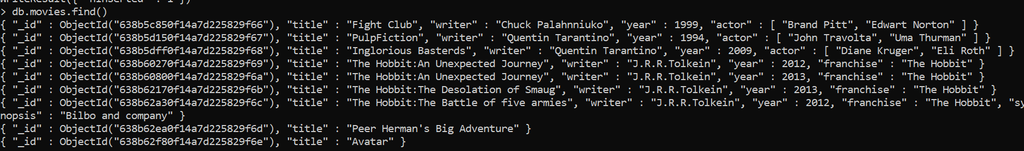

2.Get all documents with writer set to “Quentin Tarantino”



3.get all documents with movies released in 19s



4.get all documents with franchise set to “ The Hobbit”



5.get all documents movies released before 2000 after 2010



6.UPDATES

🡪 add a synopsis field to both titles of “The Habbit:Unexpected Journey” and “The Desolation of Smaug”

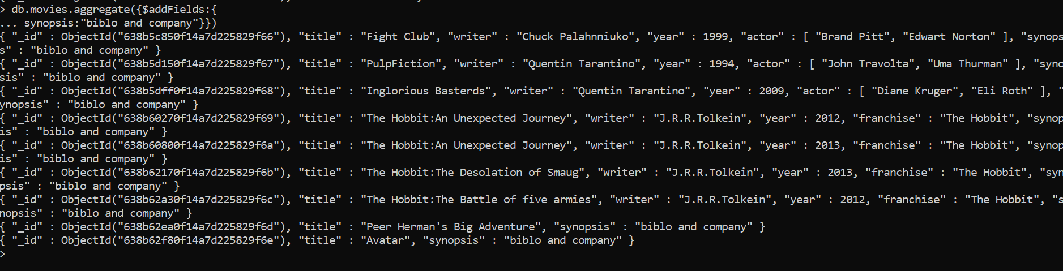

7.find all movies who have word Bilbo in synopsis.

